Proposal on

Online Movie Ticket Management System

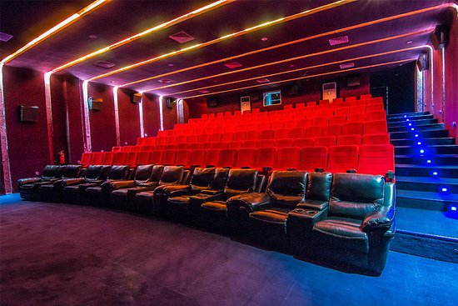

Anusha Pokharel

00175011

Computing Project

Level 5 in Computing

Softwarica College of IT and E-Commerce

Kathmandu, Nepal

09/04/2019

Submitted to:

Niman Maharjan